Project Design Phase-II
Technology Stack (Architecture & Stack)

Date | 31 January 3035
Team ID | LTVIP2026TMIDS36206
Project Name | Gemini Pro Financial Decoder: Transforming Complex Data into Actionable Insights
Maximum Marks | 4 Marks

Technical Architecture:
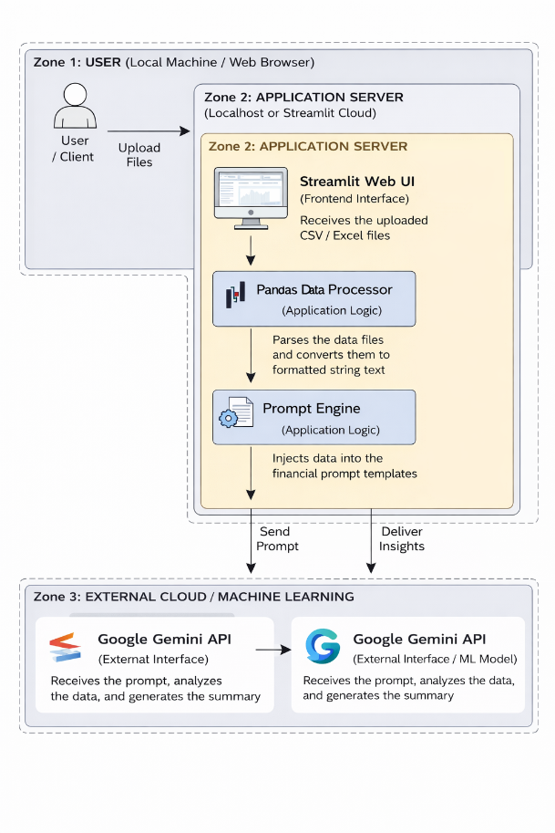

Table-1: Components & Technologies
S.No | Component | Description | Technology
1 | User Interface | Web interface for file upload and dashboard display | Python, Streamlit
2 | Application Logic-1 | Data manipulation, dataframe creation, and numeric filtering | Python, Pandas
3 | Application Logic-2 | Generative AI integration and content generation | Google GenAI SDK (gemini-1.5-flash)
4 | File Storage | Temporary storage and handling of uploaded user files | In-memory Streamlit File Uploader
5 | External API-1 | Large Language Model used to analyze financial text | Google Gemini API
6 | Infrastructure | Application deployment and hosting | Streamlit Community Cloud / Localhost

Table-2: Application Characteristics
S.No | Characteristics | Description | Technology
1 | Open-Source Frameworks | Core frameworks driving the frontend and data logic | Streamlit, Pandas
2 | Security Implementations | Secure management of sensitive API keys to prevent unauthorized quota usage | Streamlit Secrets (.streamlit/secrets.toml)
3 | Scalable Architecture | Stateless application design allowing multiple consecutive document uploads | Python / Streamlit architecture
4 | Availability | Cloud-based deployment for broad accessibility | Streamlit Cloud deployment
5 | Performance | Handling of API constraints and loading states | Python try-except blocks, time.sleep(), Streamlit st.spinner

